
The Desert Resort
  - Website objective and Business Goals
  - About us
The Desert Resort is an organization amid to bring the very best of what African tourism has to offer and bring divers personal from all over the world for a once in a lifetime experience.
  - Website specifications:
Objective
The primary objective of this website is to provide a seamless digital gateway to luxury desert tourism nonnative or for foreigners visiting for an experience they will never forget.
  - Goals
- Brand Awareness: Establish high-end digital presence that reflects the exclusivity of the resort.
- Lead Generation: Convert visitors into guests through an integrated booking and inquiry system.
- Information Hub: Serve as the definitive source for accommodation details, safari activities, and resort amenities.

  - Target Audience (Demographics & Technical Aptitude)
Demographics: International and local luxury travelers aged 25-65. Typically, high-income earners (HNWIs), honeymooners, adventure enthusiasts.
Technical Aptitude: High, User are expected to be proficient with mobile device and desktop browsing, expecting fast load times and intuitive UI/UX.
  - Website Type and Content
The site is a Commercial/Hospitality Service Website. Contact include high-resolution images galleries, virtual tours, a dynamic booking Calander, and blog post detailing local safari flora and fauna.
  - Information Design & Taxonomy
The website follows a hierarchical taxonomy to ensure guests can find information within three clicks.
Information Architecture (Site Map):
- Home: Hero video, quick-book widget, featured testimonials.
- Accommodation/Explore suits: Luxury Tents, Private suites, Family Villas.
- Experiences: Dune Bashed Tours, Stargazing, Camel Safaris, Family Villas.
- Gallery: Visual showcase of the resort and surroundings.
- Contact/Booking: inquiry forms and Booking forms.
Storyboard Flow.

Storyboard Flowchart:
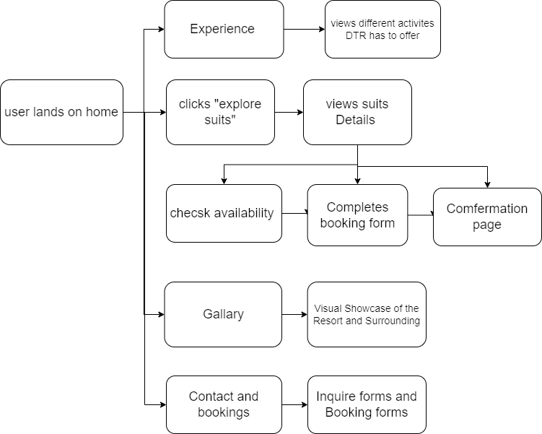
  - Technical Brief
To Match the resort’s premium nature, the following stack is utilized:
- Frontend: HTML5, CSS3(using Flexbox/Grid for responsiveness), and JavaScript (ES6) for interactive elements.
- Graphics Tools: Adobe Photoshop for image optimization and Figma for UI/UX prototyping.
- Frameworks: Bootstrap 5 for rapid responsive grid deployments.
- Version Control: Git for managing codebase iterations.

